**Sreeraaghav Raja**

**1/19/2026**

**EE Design 1 Technical Report**

**PCB Design**

**Introduction**

The purpose of this module is to familiarize the students with the entire Printed Circuit Board (PCB) design process. The lab takes the student from first designing the schematic and implementing bypass capacitors to finalizing a PCB layout and eventually finalizing the design by performing a design rule check. While the components are ported onto the PCB quickly after making the schematic, laying out the components in a sensical manner on the PCB was a difficult part of the lab. This was the main element of the lab because creating the schematic was trivial.

**Methods**

The PCB design and Schematic were both created on Altium. This necessitated uploading libraries that were aligned with the components on the schematic given that was meant to be laid out. This meant learning a few pieces of background information regarding this lab assignment:

1. **How are external libraries imported into Altium?** 
   1. *External libraries are imported by first navigating to the “Libraries Preferences” tab on Altium [7]*
   2. **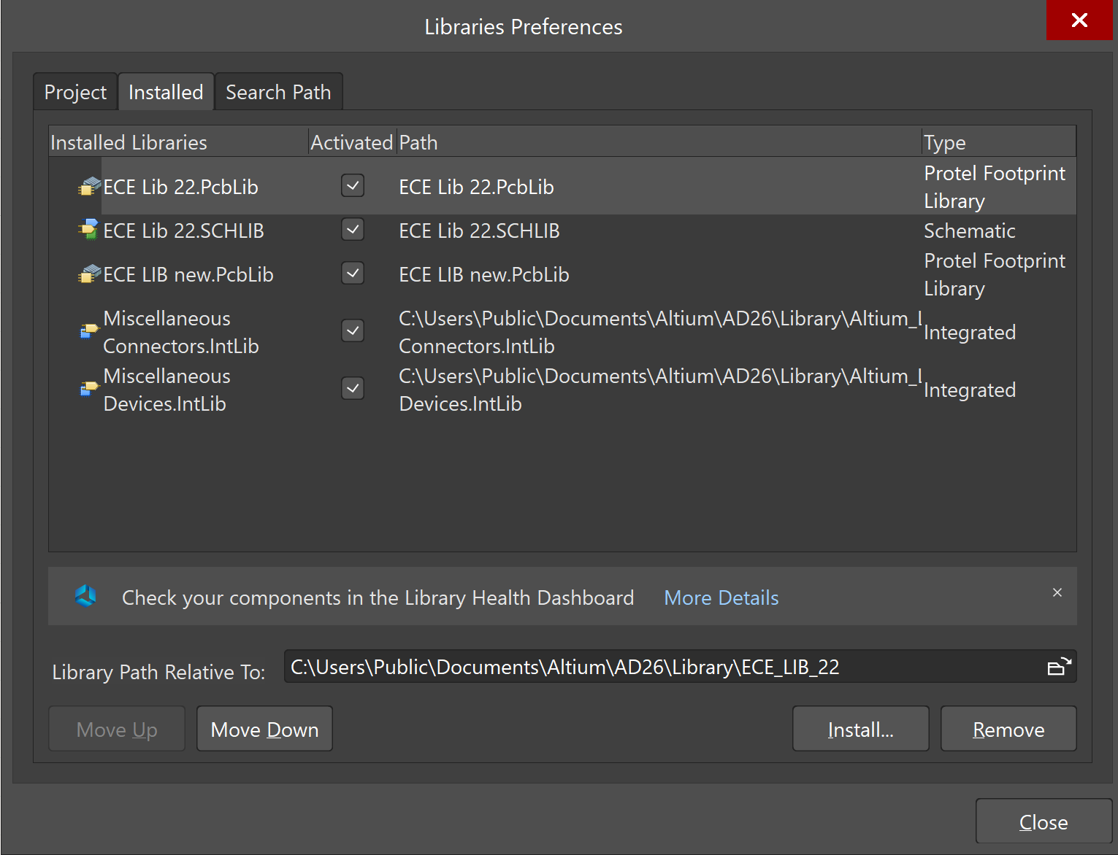***Once the user has navigated to that tab, click “Install” and find the Intlib, PcbLib, or .SCHLIB files that are connected to the specific libraries that are necessary to install [7].*
2. **Why are power, input, and output connected on the schematic?**
   1. *Power, input, and output are connected to the schematic by using header components. These components are specifically downloaded through an external library called “Miscellaneous Connectors” [6].*
   2. ***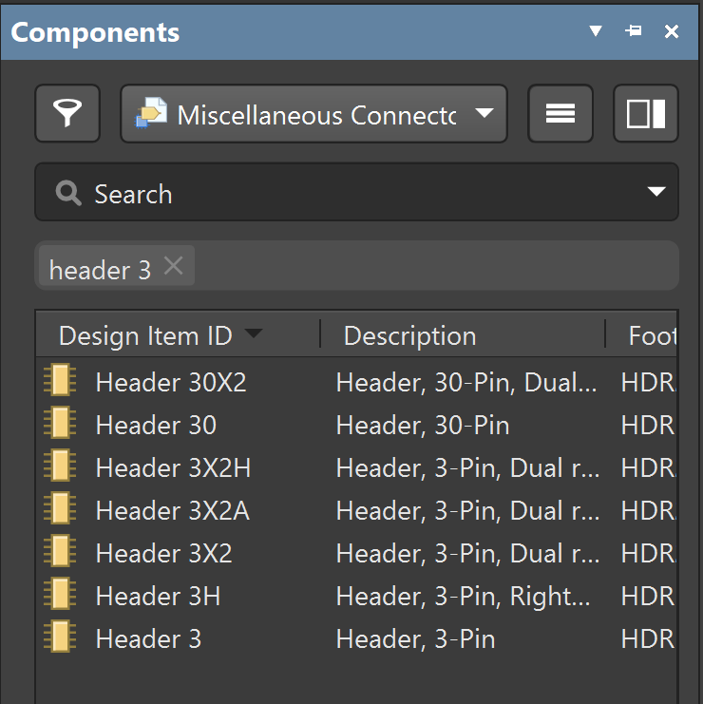****Power, input, and output connectors are necessary since they interface with environment in way. The PCB is essentially a black box until the I/O and Power pins are connected.*
3. **Why are bypass capacitors important (i.e., what do they do)?**
   1. *Bypass capacitors are important because they prevent the distortion of a DC power source through Electromagnetic Interference (EMI) [5]. The bypass capacitor has a low-pass filtering effect that provides “infinite resistance at steady-state voltage and bypassing high-frequency noise” [5]. This will limit the noise on the power line.*
   2. *Additionally, electrolytic capacitors may be useful as bypass capacitors because they also limit lower frequency noise that may not be part of the DC power source. This is also useful for active devices which will require a power source of some capacity [2].*
4. **Where should bypass capacitors be placed on board?**
   1. *This was partially answered above, but bypass capacitors should be attached to power sources and any devices that require power sources to operate. This is important as a minor error in a power source could lead to a much greater issue in a circuit that could compound with every additional device [4].*
5. **How are components in the schematic imported into the PCB?**
   1. *Components are imported into the PCB by updating the schematic first and then navigating to the Design tab on the Schematic document.*
   2. *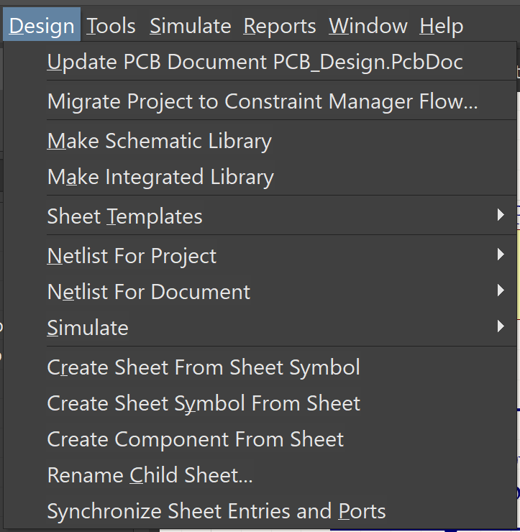Once there, select update PCB <document_name> and the components should all appear on the PCB document [3].*
6. **Explain the board outline and keep-out layer.**
   1. *The board outline is meant to define the board’s shape, and this is used in conjunction with the keep-out layer [3]. The keep-out layer is an area where there is no copper and this is used in conjunction with the board outline to constrain the board’s shape to match a certain desired size constraint. The keep-out later is also particularly useful when deciding how to connect different modules together. Areas on a PCB can be defined as a “Keep-Out” area where certain groups of objects are constrained to and they cannot be moved beyond that area [3].*
7. *How was the PCB planned out?*
   1. *The PCB was planned out based on the sizing, type, and location of the components that were available in my design. Ceramic capacitors were placed together if they were close to one another on the schematic. However, if the components were connected to completely different sections, then they were not connected. This was mainly primarily based on intuition for how different elements would be connected. For instance, the amplifier design has all 3 electrolytic capacitors at the top because they aligned properlyl with the Op-Amp and Power Source of the circuit.*
   2. *Interestingly, the Power Input and the I/O are on opposite sides of the PCB because it limited the number of crossing connections when routing the PCB. However, the placement is primarily a result of the philosophy used to place the devices on the PCB originally. The PCB has an “aesthetic” quality which may have helped limit the crossed connections at the expense of the power and I/O headers being separated.*

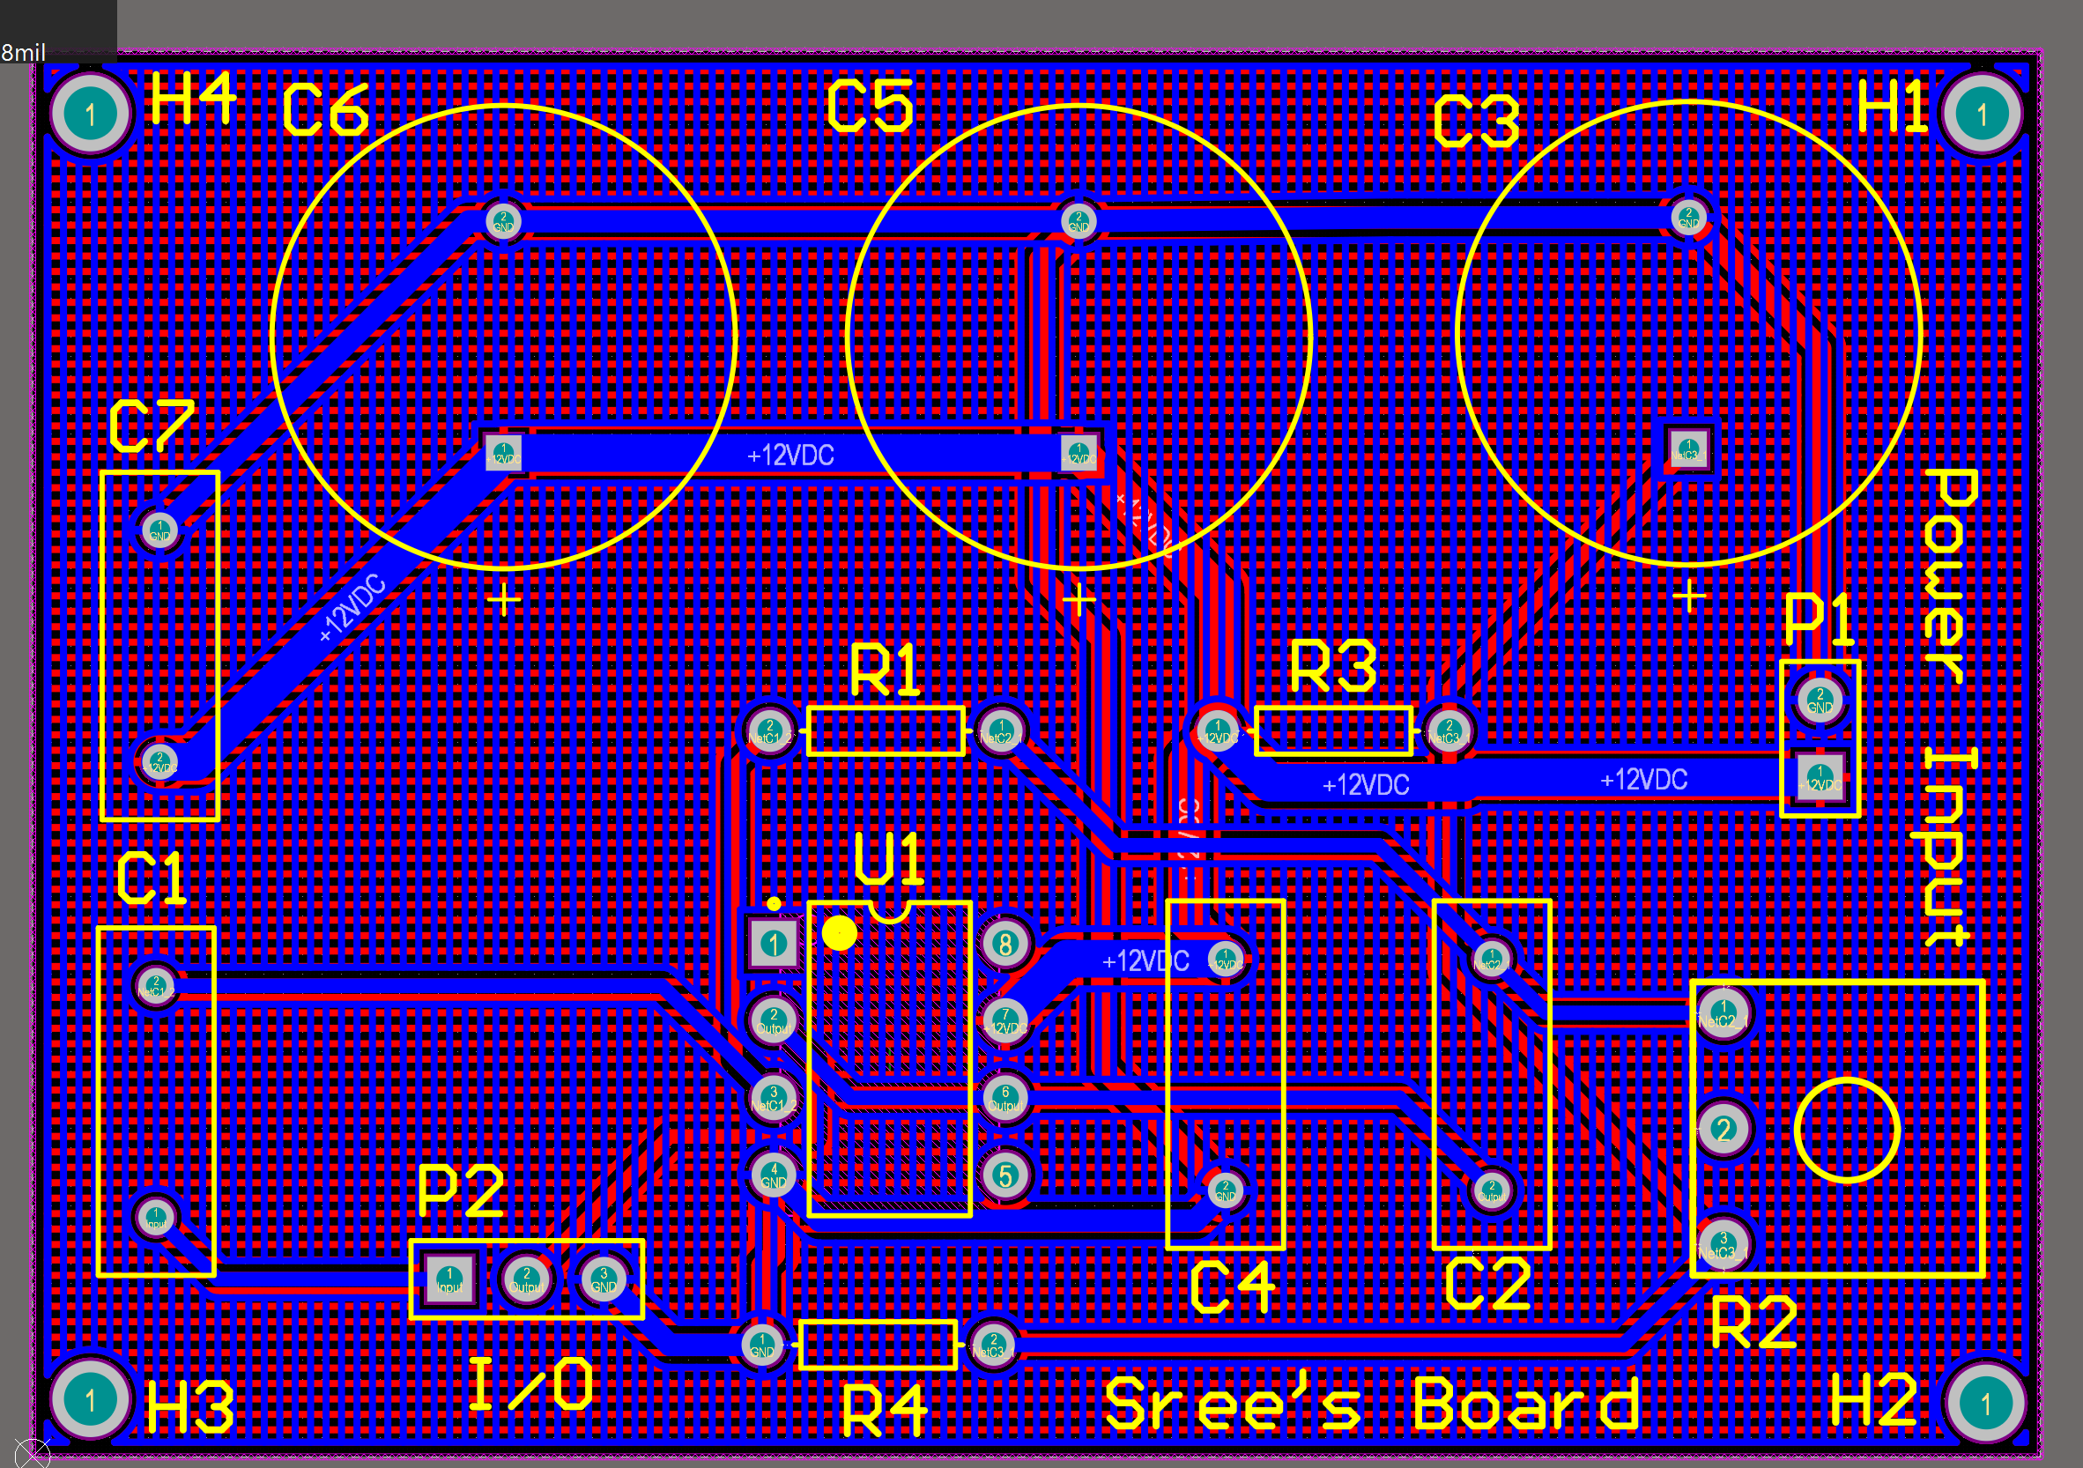



1. **Why does the power source have multiple electrolytic capacitors?** 
   1. *The primary reason was logical failure since it was assumed that the power source input will always require both an electrolytic and ceramic capacitor for both low-frequency and high-frequency noise. However, having multiple electrolytic capacitors at the output may not actually affect the decoupling effect as they are both in parallel. This creates a larger capacitance in parallel, so the result may not differ too much as the overall equivalent capacitance remains at a range that is still viable for low-pass filtering. Instead of 100uF, the capacitance is 200uF. Overall, the RC time constant increases by a factor of 2, so the low pass filtering effect is effectively enhanced by increasing the capacitance, albeit this should be a negligible difference for the overall circuit.*

**Results**

The primary results of this lab are **the Schematic**, the **PCB**, and the **Design Rules Check (DRC)**. DRC rules are always necessary for any industry-level design since these designs are meant to be manufactured and exported to a larger market. Therefore, passing DRC rules will ensure that a design is safe and reliable. This is vitally important for IC layouts as they are effectively the building blocks of much more complex circuits / circuit components. Naturally, this extends to PCBs as they harbor many ICs and abstract the finer elements of the circuit-building process from the worldwide market. **Essentially, a company will commission a PCB, and if it reliably meets performance benchmarks, then the design is approved.** However, this requires the designer to meet the company’s design specifications along with the generic DRC Rules.

The schematic was the part of the lab that was completed. This is essentially a carbon copy of the given peaking filter schematic. A peaking filter is effectively the opposite of a notch filter. Instead of attenuating signals at a range of frequencies, it amplifies signals at that narrow band of frequencies [1]. Therefore, it is vital that the power source is decoupled as it could lead to errors in the actual circuit with unnecessary harmonic signals from low-frequency or high-frequency noise.

Figure 1: Peaking Filter Reference Schematic

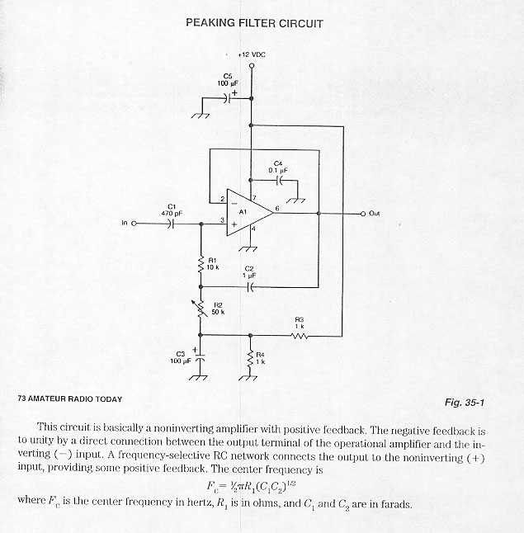

The general schematic is the same as the reference schematic with a few exceptions:

The **power input** circuit provides power and earth ground, which is only necessary in a few cases, to the rest of the circuit. These are connected to headers which will support external power input and ground input for the PCB. The power input circuit is highlighted by a red box in the schematic image.

The **Input/Output (I/O)** of the schematic is indicated with by a blue box. The header is a 3-pin header, and it supports an input signal, output signal, and an additional ground signal. The purpose of this element is to read the internal condition of the PCB. Without the I/O Module, then the PCB is an unreadable “Black Box.”

The **Holes** are indicated by the green box, and they are detached from everything else on the schematic. The holes are essentially 3 mm open sections on the PCB that will help attach it to a larger module. These holes are not necessary for this lab, but they were simply useful to know about and implement on the PCB.

Figure 2: Peaking Filter Schematic

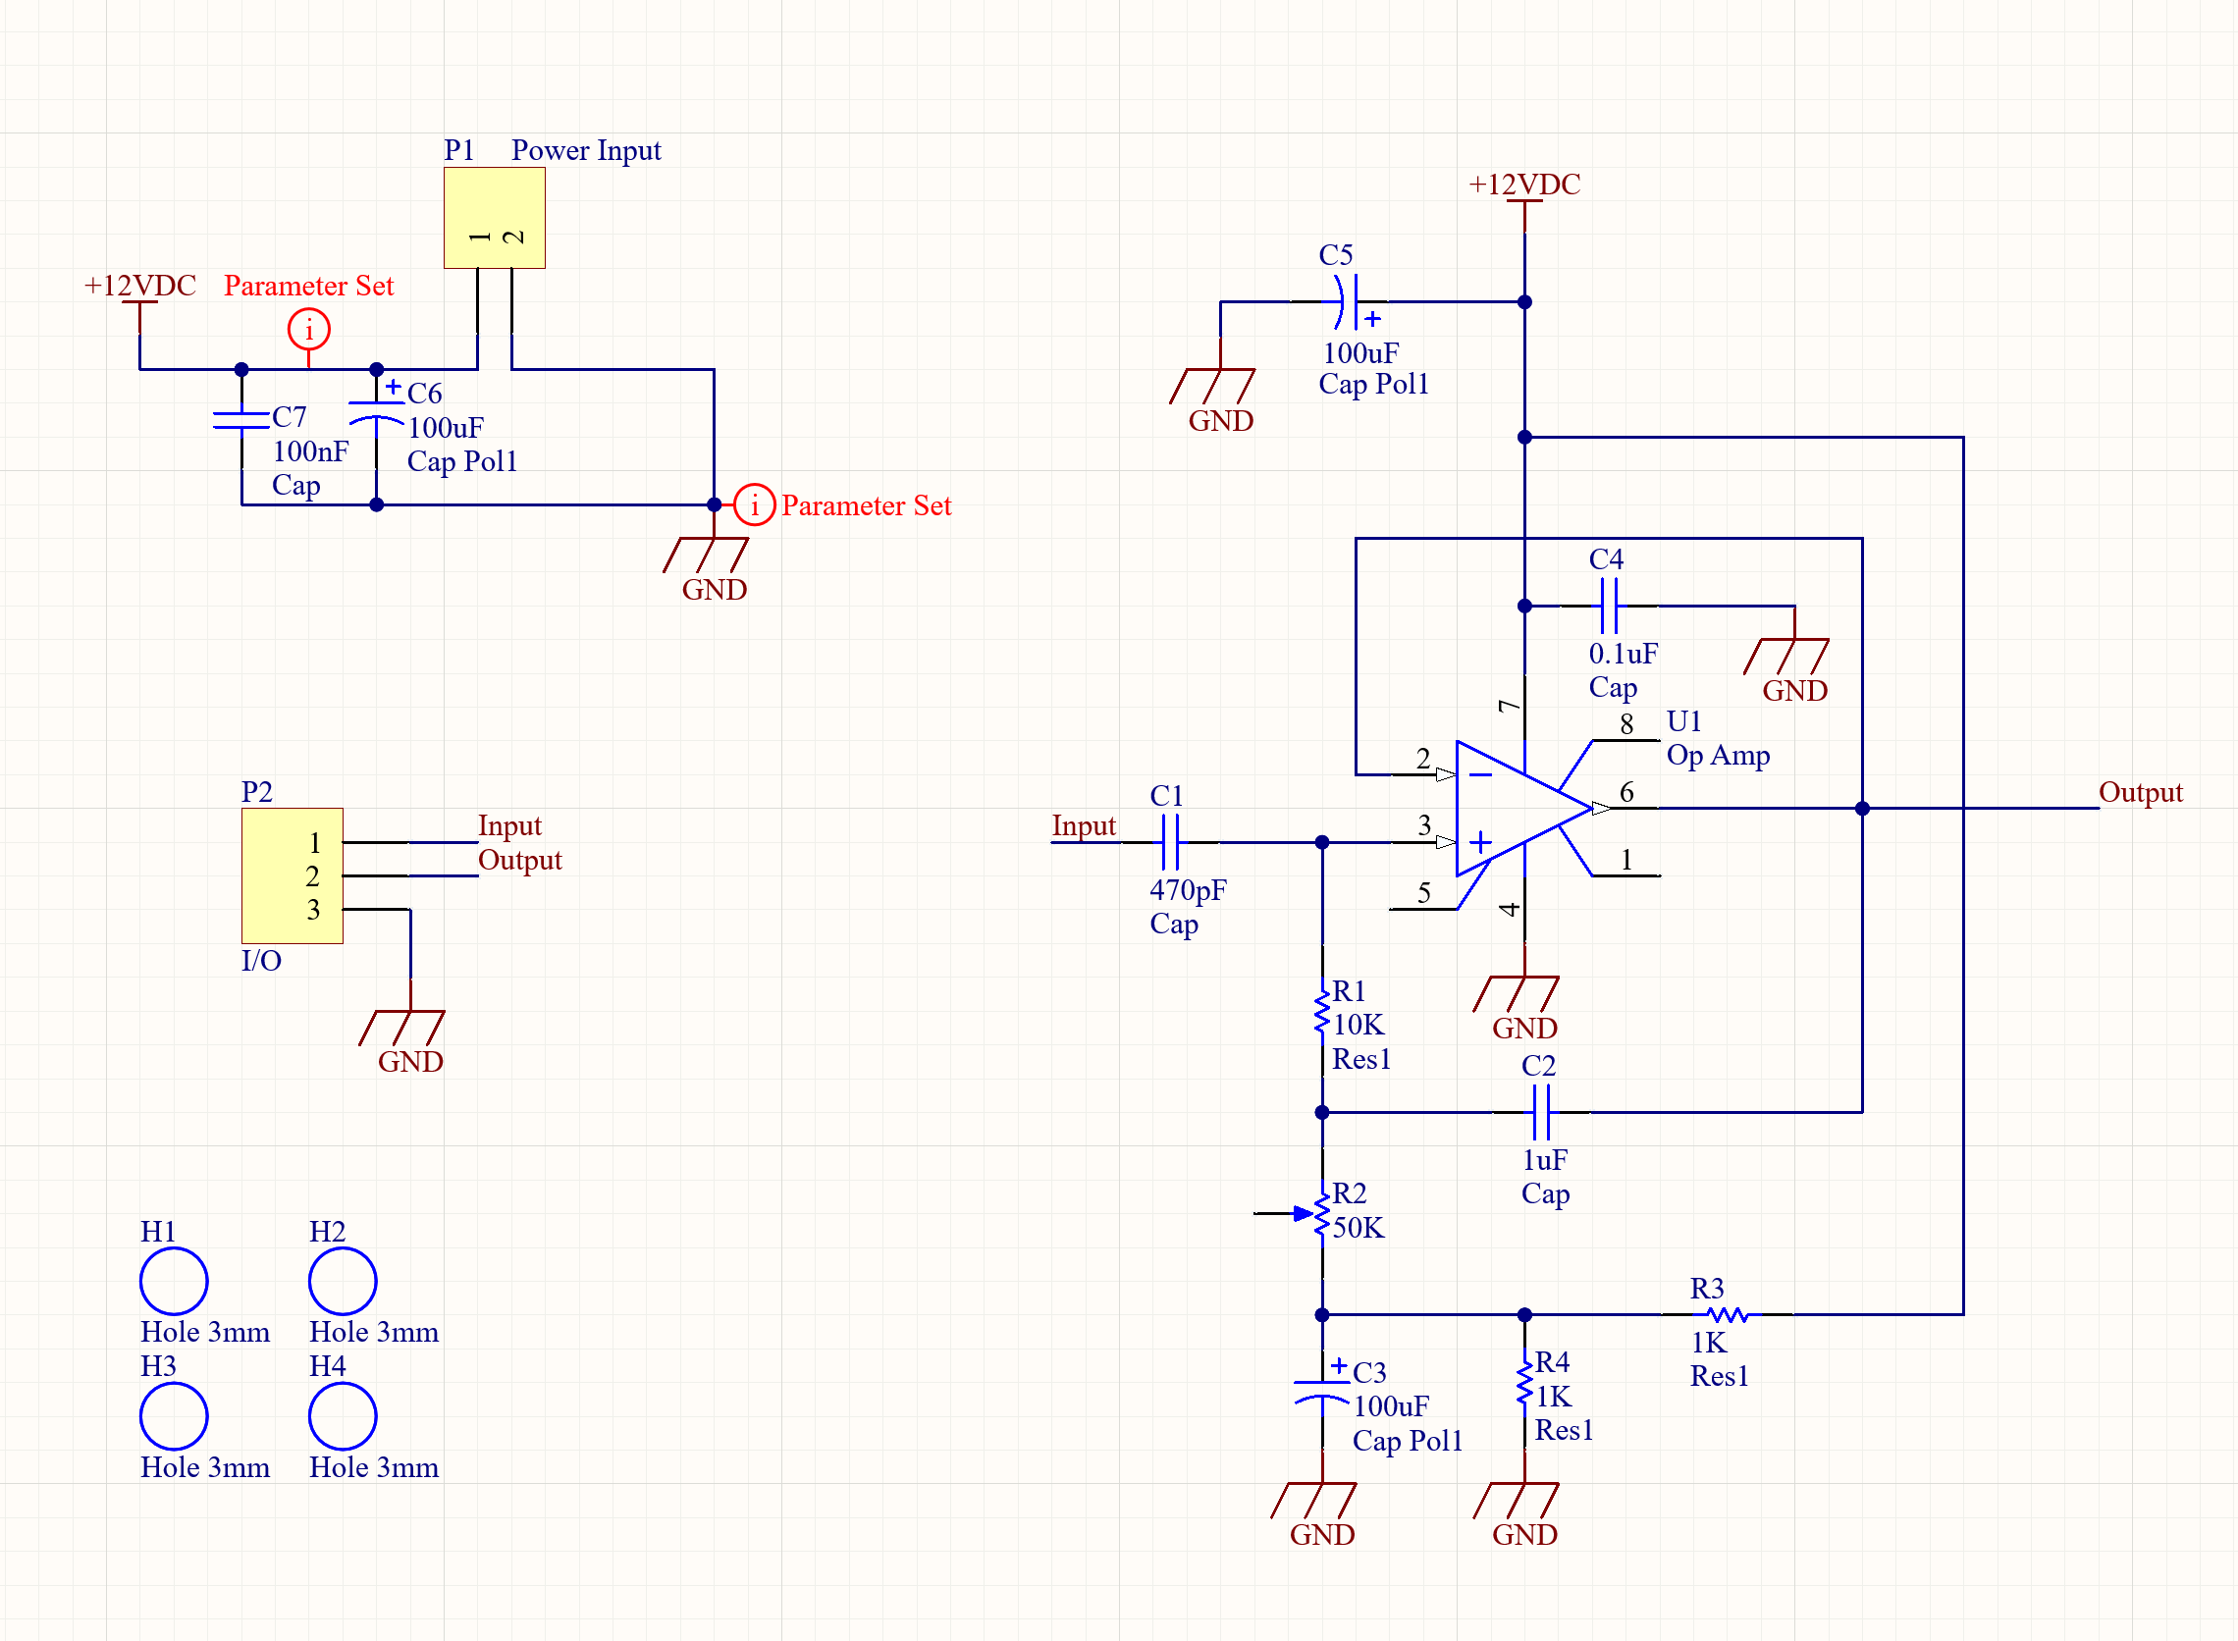



The PCB is the largest part of this lab and was much more involved than the schematic. Porting the components from the schematic to the PCB was trivial, but routing and moving everything to a reasonable position was difficult. The PCB dimensions are **2600 mil x 1820 mil** which is a relatively small form factor given the schematic. There are multiple versions of the PCB that are necessary to show, and each one is provided below:   
  
 The first version is the PCB view from the Top Layer. The Top Layer has a horizontally aligned copper pour that is attached to the +12V line. These lines are all highlighted in the corresponding image of the PCB.

The second version is the PCB view from the Bottom Layer. The Bottom Layer has a vertically aligned copper pour, so it looks like a crosshatch when it is superimposed over the Top Layer. The Bottom Layer’s copper pour is connected to the GND line, so those lines are all highlighted in the corresponding image of the PCB.

The third version is a multilayer composite image of the PCB. This image shows the PCB with a darker green tint. The holes, even for the components, are all gray and the crosshatched copper pour design is apparent in this image. The +12V, GND, and intermediate rails are all apparent in this design, but they are less apparent than the single layer views.

The final version is just the top layer view of board. This shows the color of the PCB when printed, a subtle, bright green. The holes are encased by copper on every component, and a 3-dimensional view of the board is accessible with this perspective. This is the essentially a view of how the circuit would look once complete.

Figure 3: Top Layer view of PCB with +12V Copper Pour

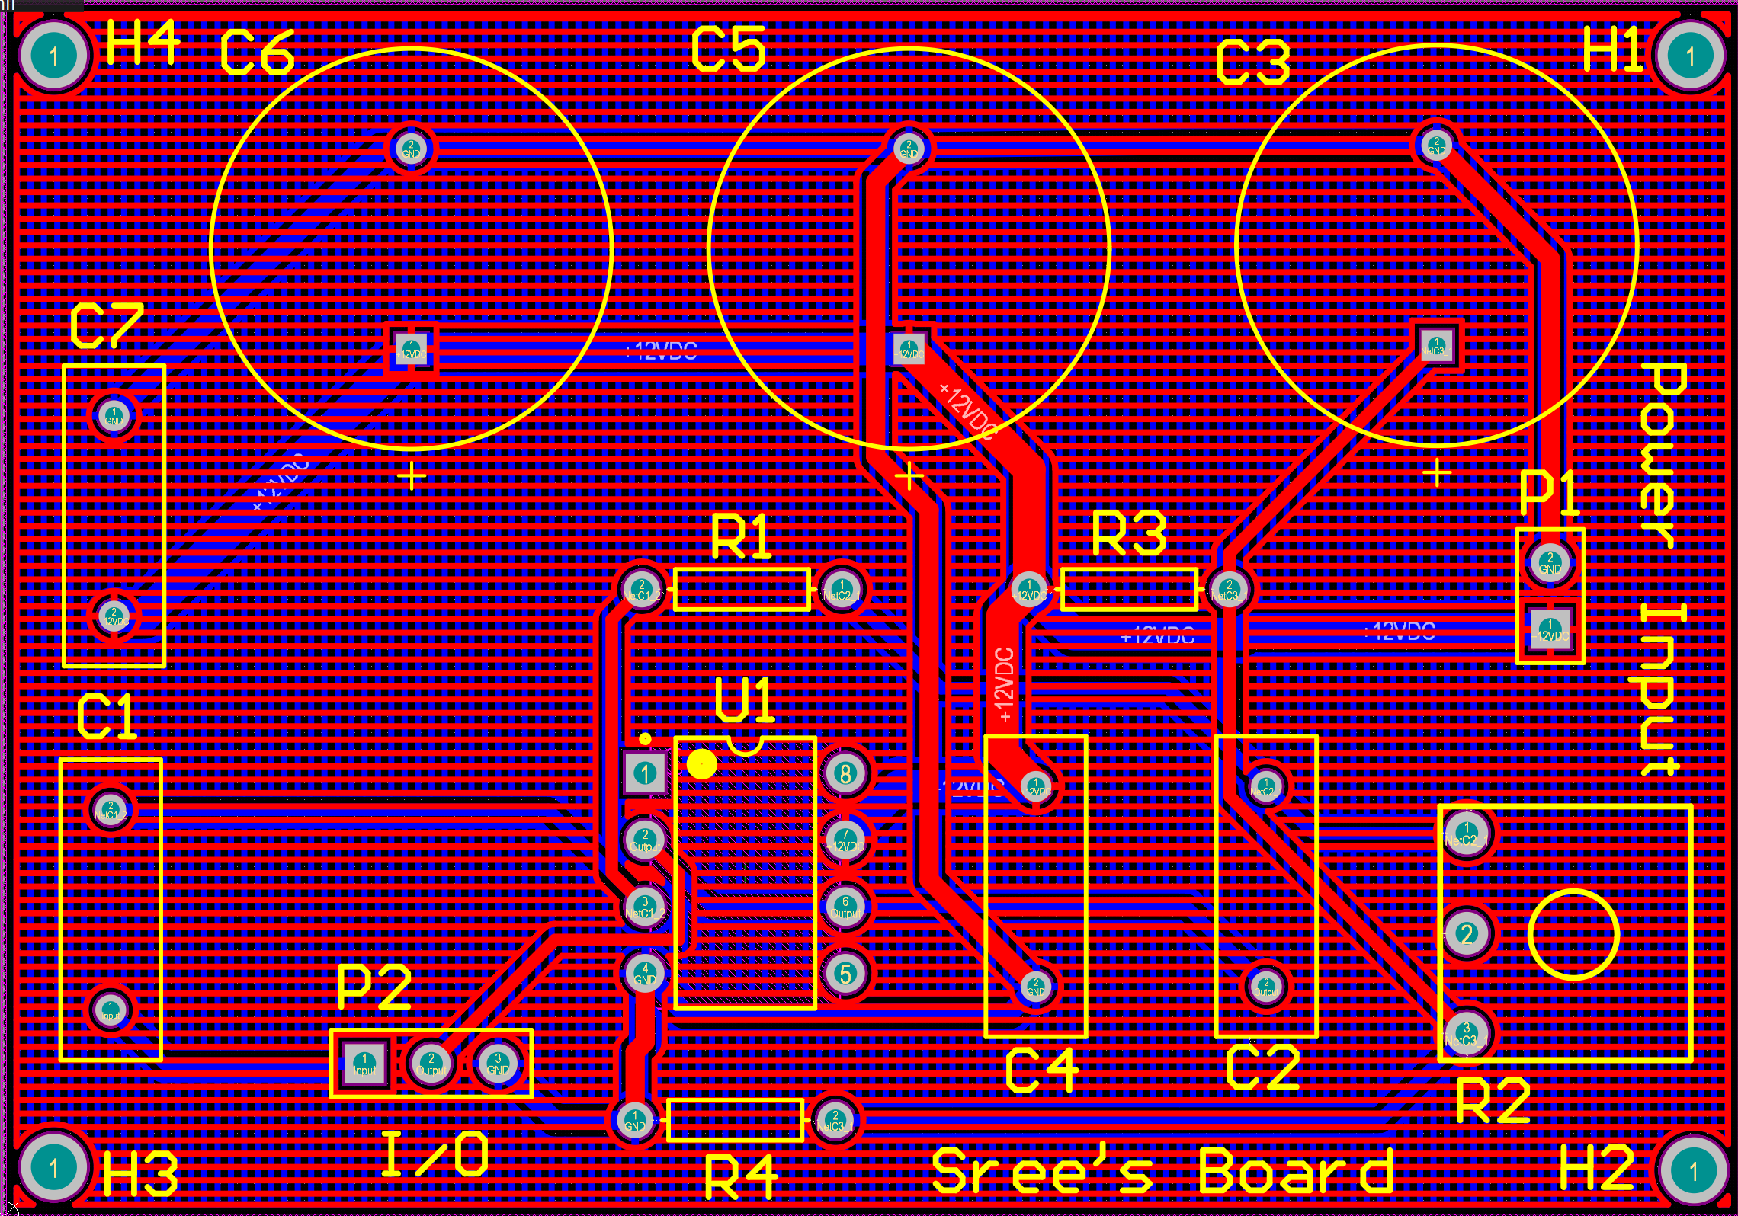

Figure 4: Bottom Layer Image of PCB with GND Copper Pour

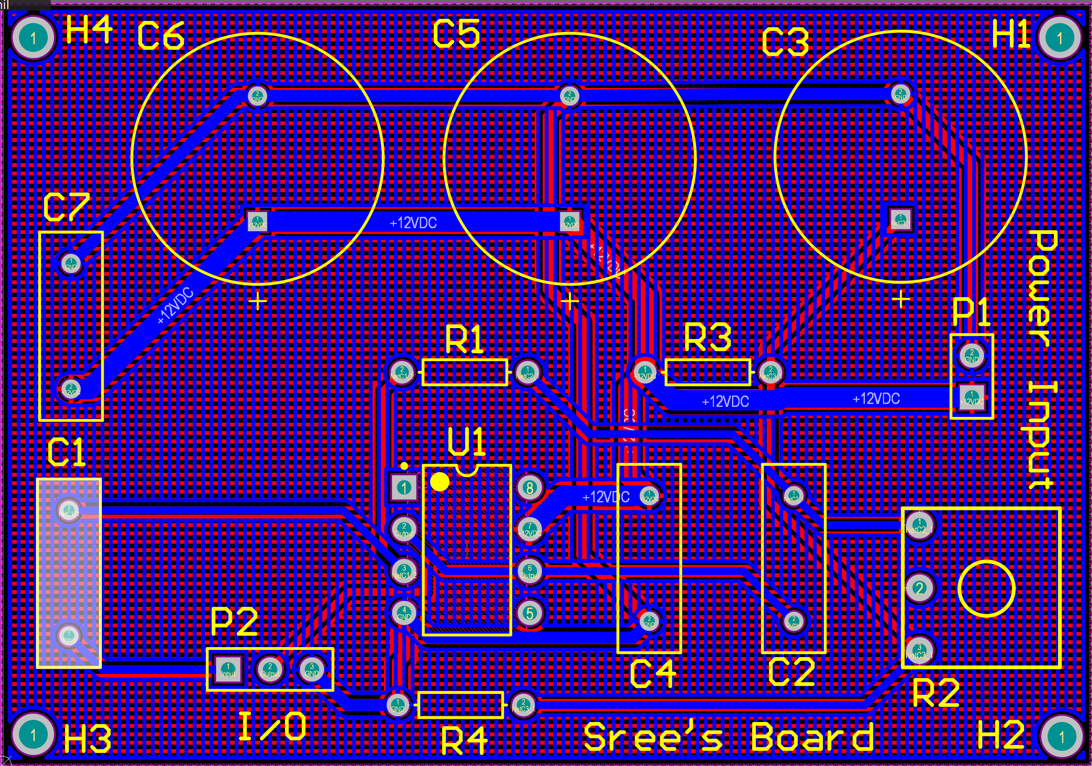

Figure 5: Multiple Layer Image of PCB

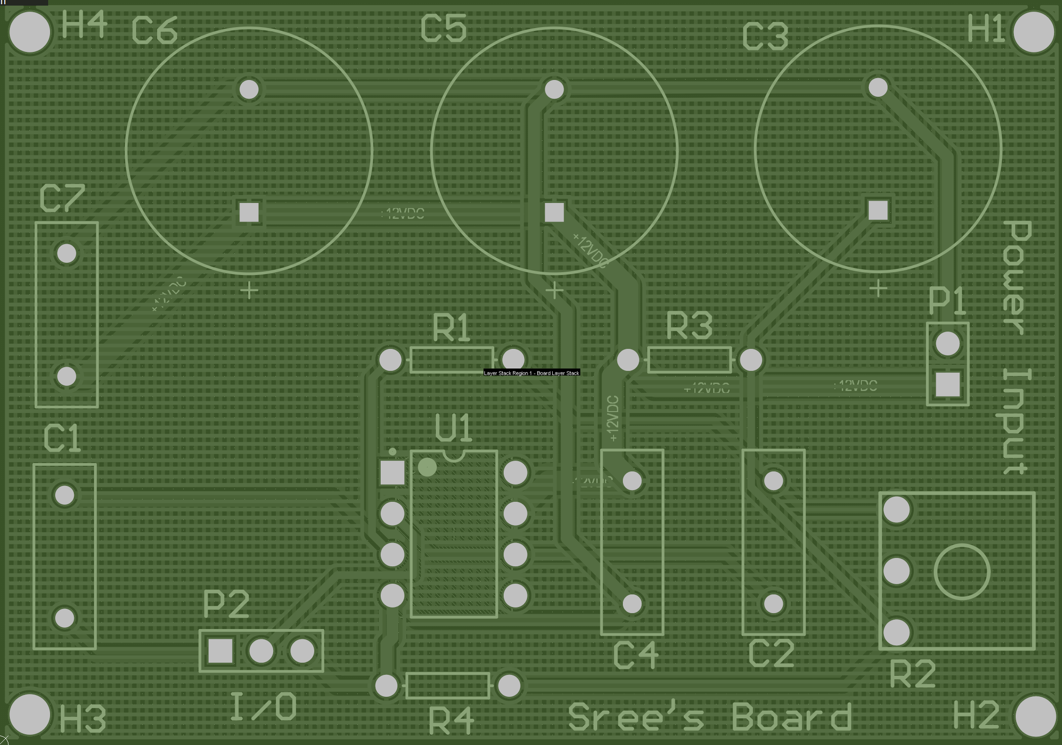

Figure 6: Top Layer Image of PCB (top)

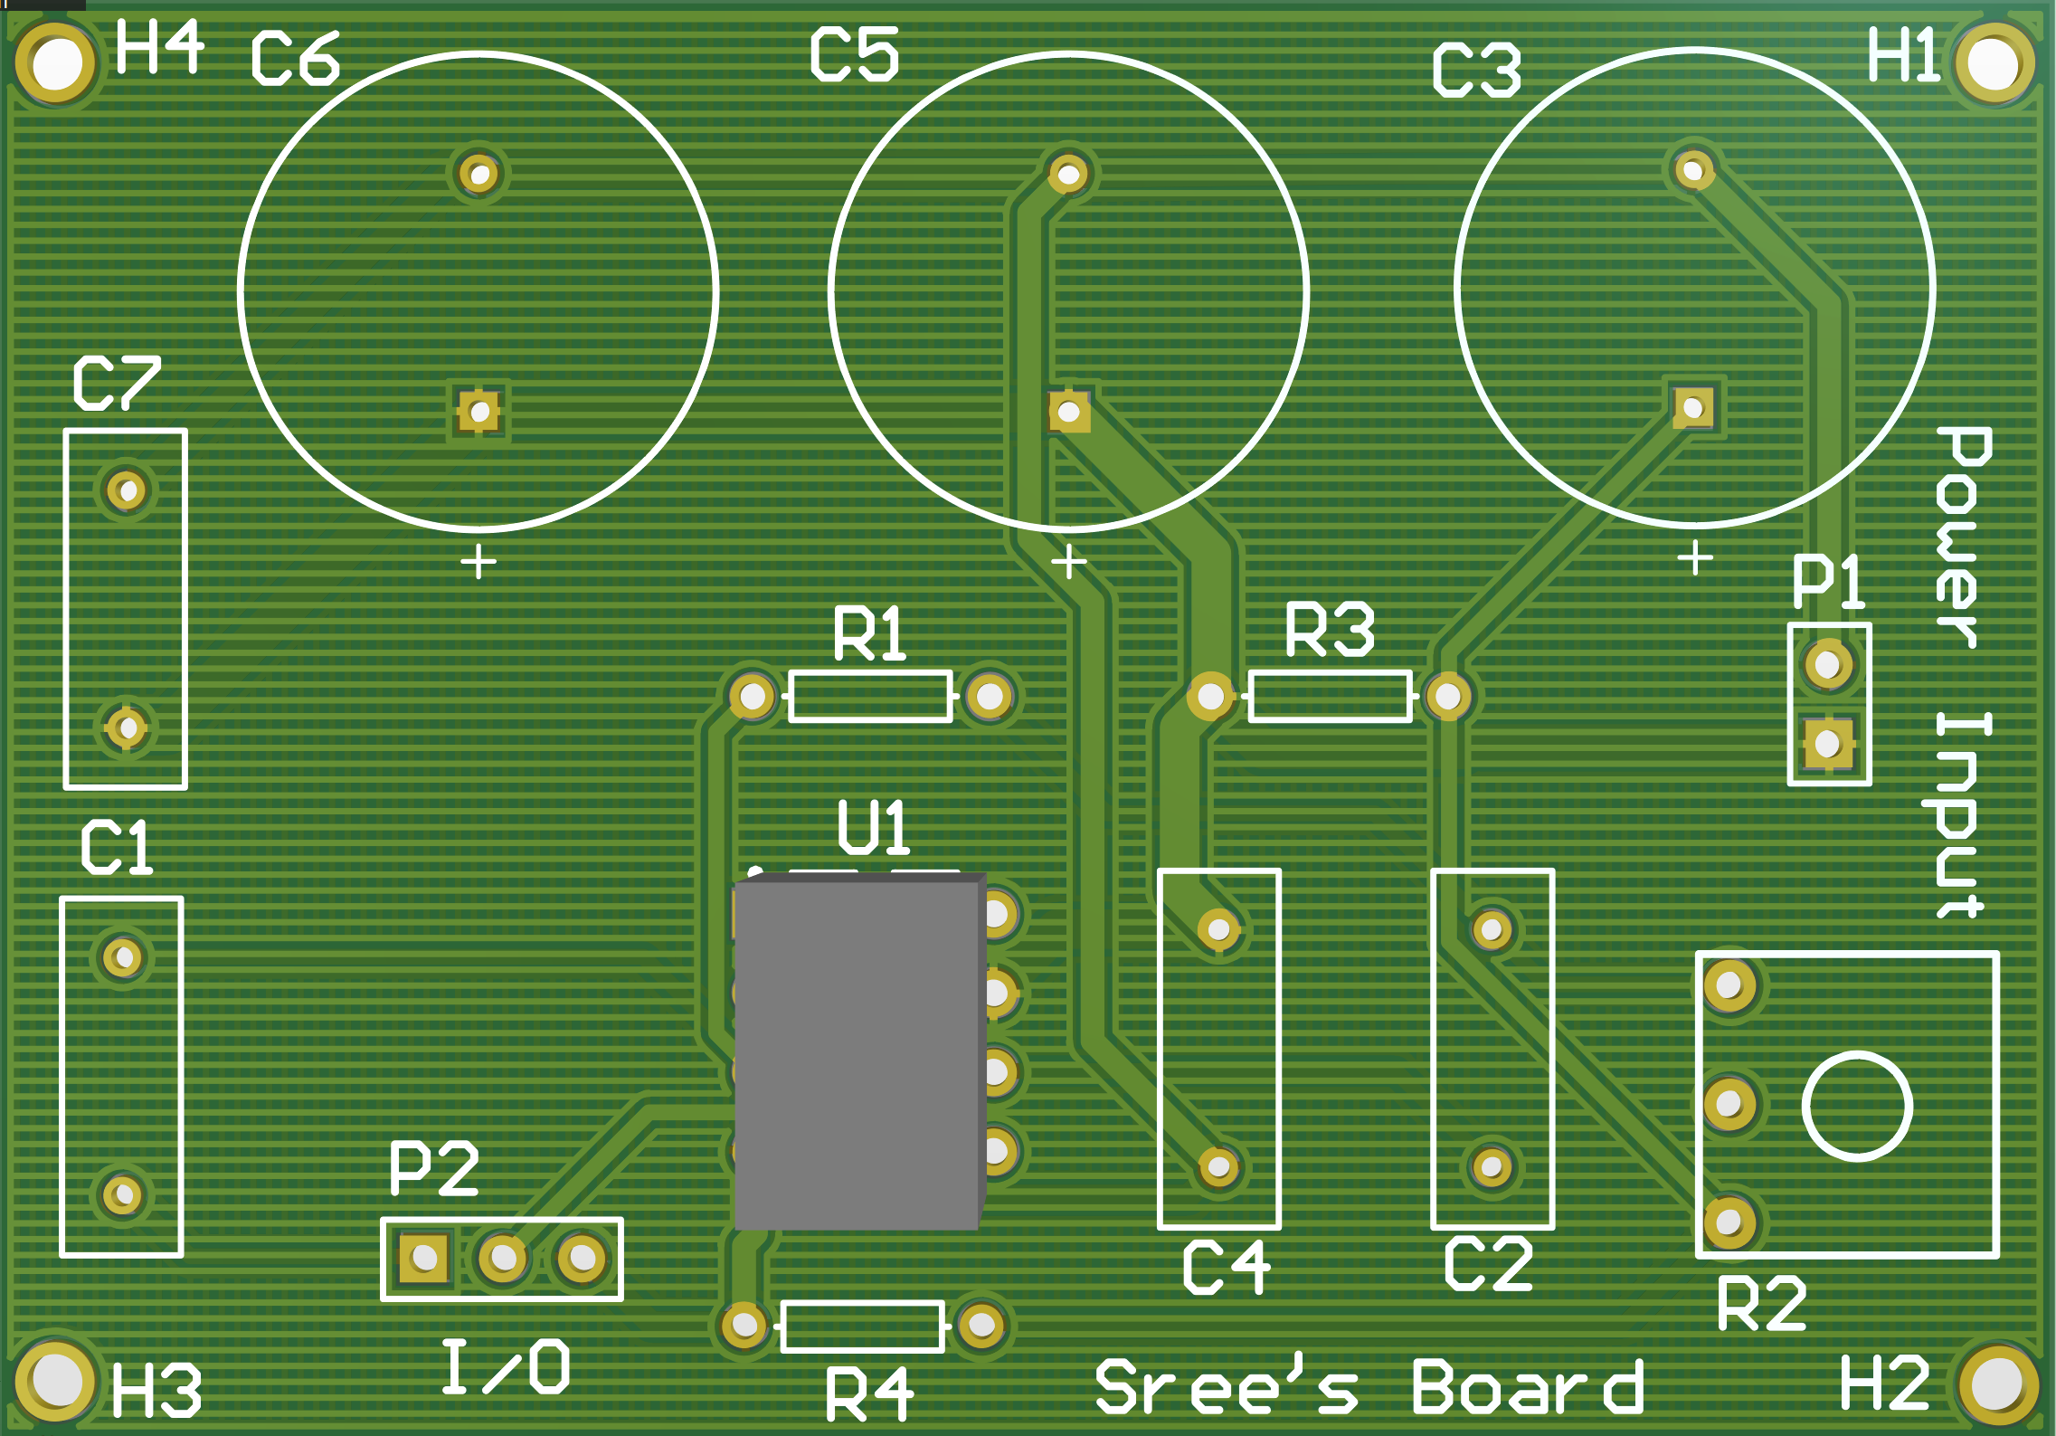

Figure 7: Top Layer Image of PCB (Flipped)

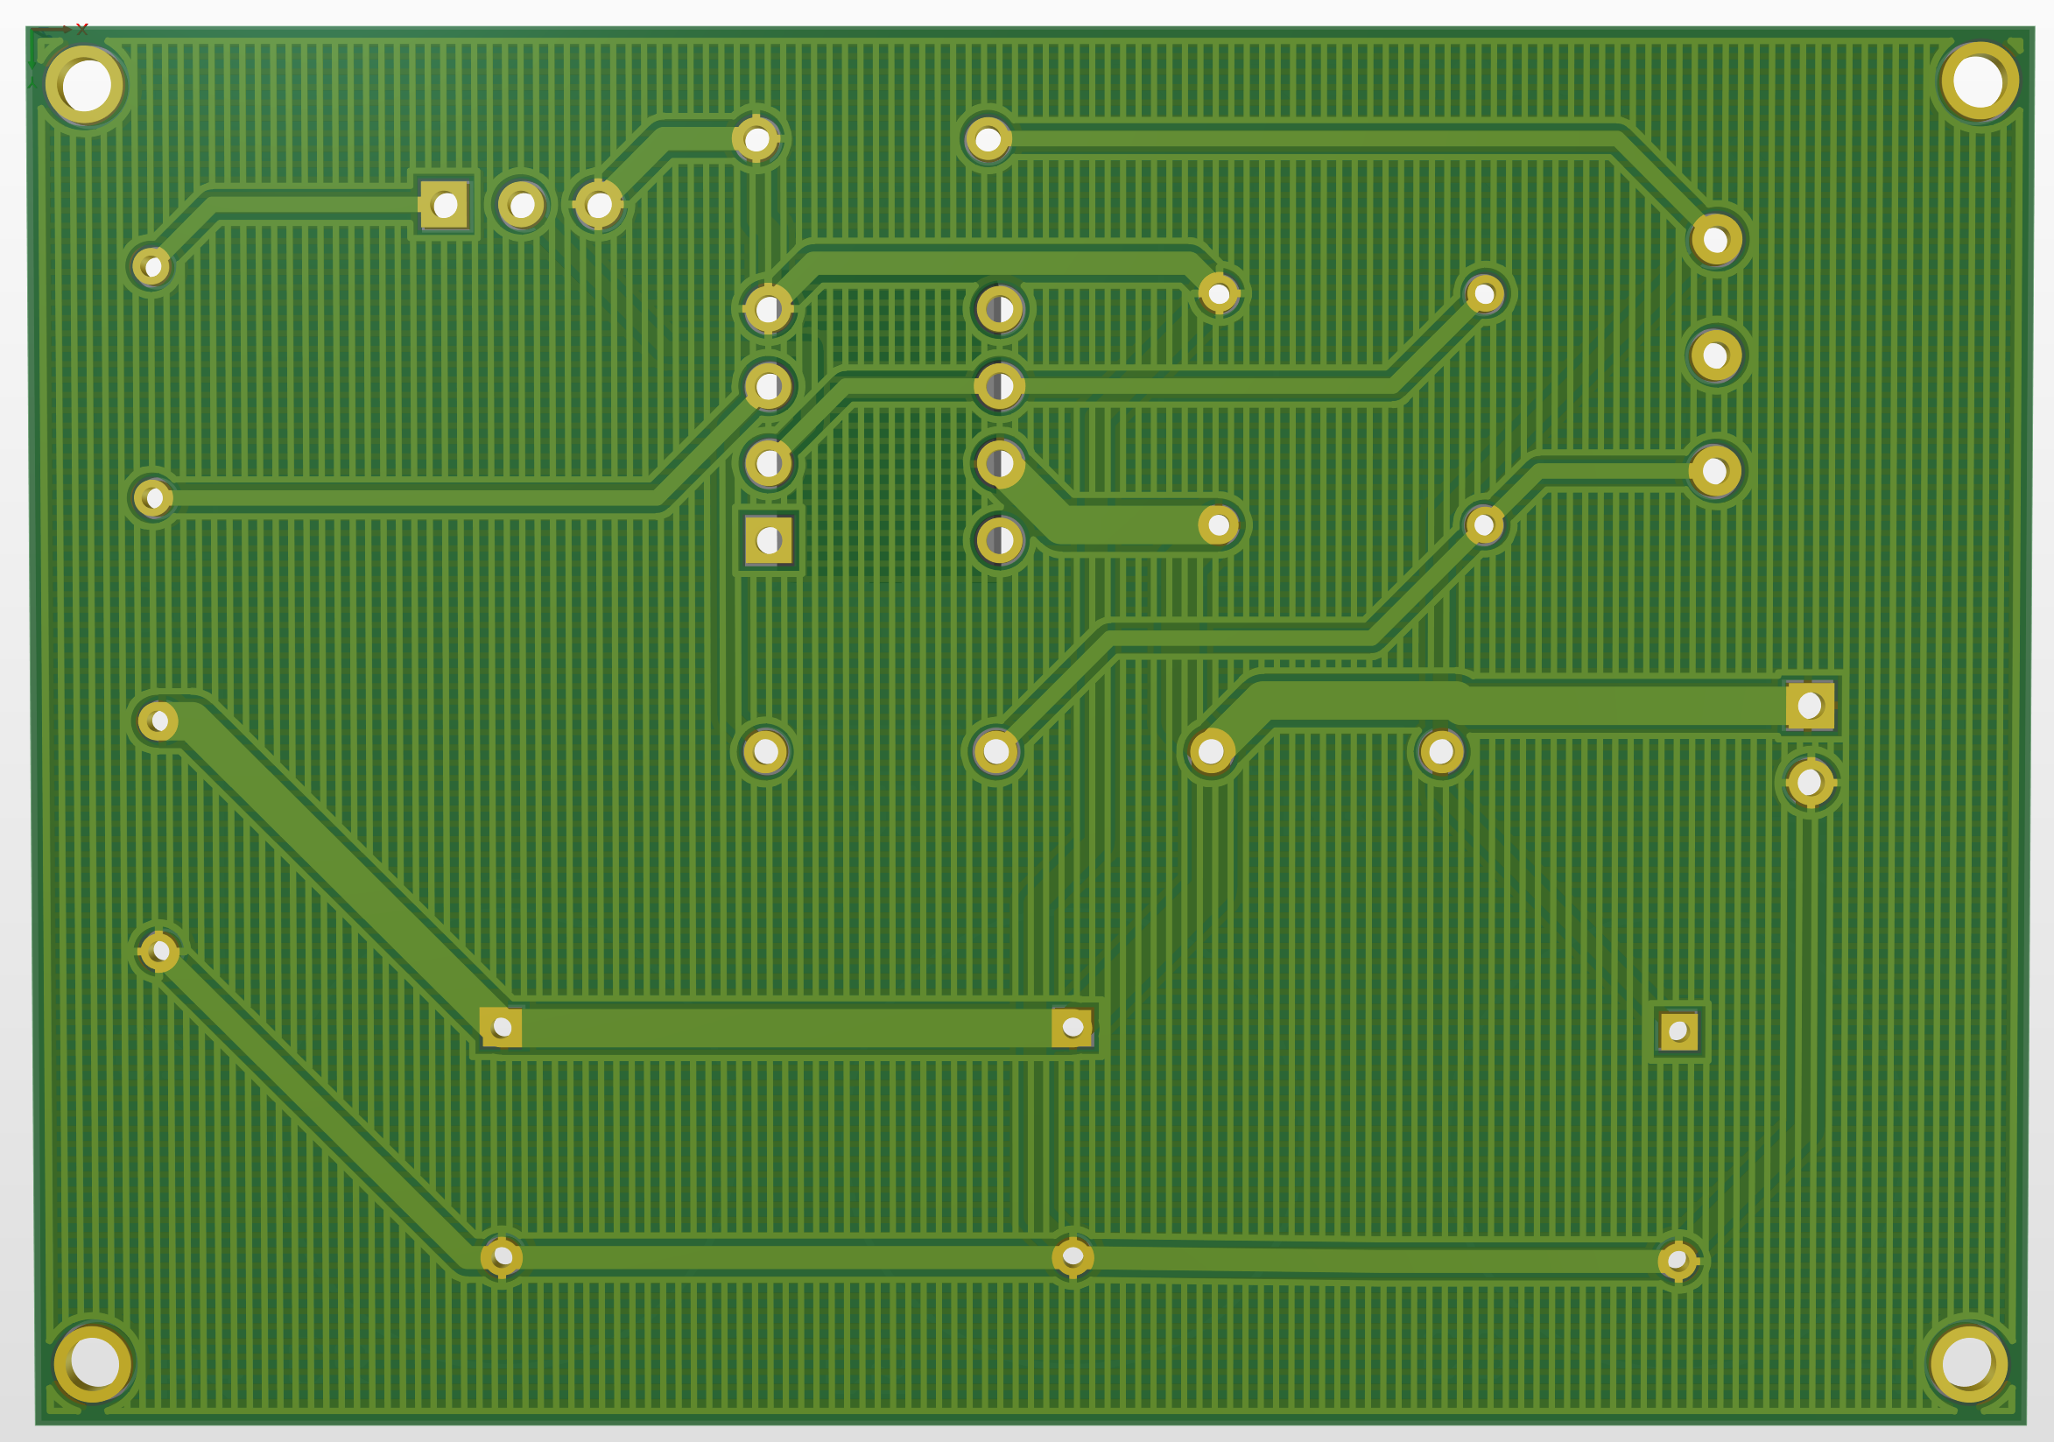

The most tedious issue was changing the footprint of the **Op-Amp to 8-pin DIP Switch Package.** Routing was simple because of the **Auto-Route** feature on the Altium which will be used sparingly. However, for this lab the auto-route feature was useful since it was an introduction to Altium, and the design was not meant to “function” for a particular use-case at this time. Nevertheless, the design passed all the required design rule checks. The only design rules that were not passed were **Silk to Solder Checks** which involve masks on the PCB and are beyond the scope of this lab.

Figure 8: Output Image of Design Rule Check

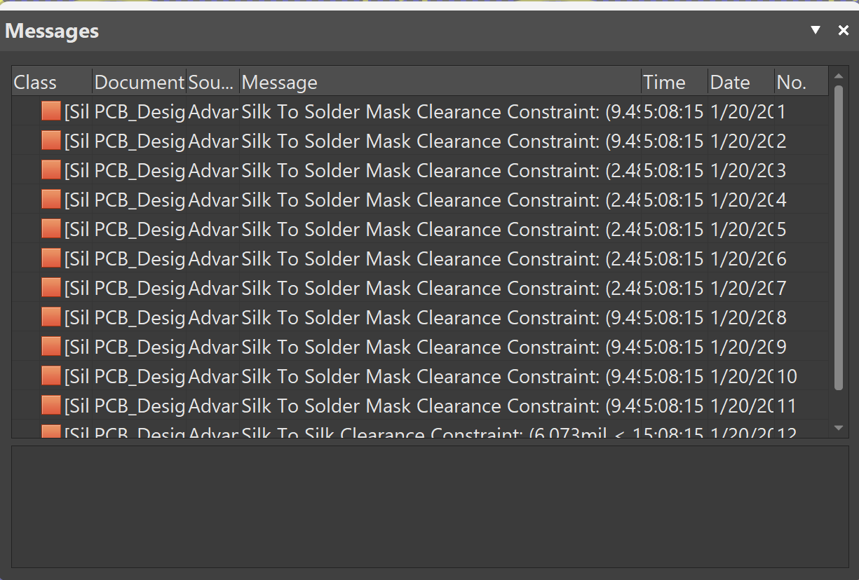

**Conclusion**

In this lab, the focus was the use of Altium and familiarizing students with using the software. Altium is not commonly used on lower-level classes as basic knowledge of circuit theory is not enough for this software. The software is an industry standard for porting over circuits on a breadboard to an actual synthesizable and reproducible design. PCBs are significantly more useful than breadboards for a variety of reasons, but a major one is that their results are easier to control using Design Rule Checks (DRC). Therefore, this lab was a necessary introduction into using a software which will appear across a wide range of fields and situations for any electrical engineer.

***References***

[1] “Product documentation,” NI, https://www.ni.com/docs/en-US/bundle/labview-digital-filter-design-toolkit/page/notch-and-peak-filters-digital-filter-design.html (accessed Jan. 20, 2026).

[2] F. Engineer, “What are the Decoupling capacitors? How to select Decoupling / Bypass capacitors?,” YouTube, https://www.youtube.com/watch?v=KKjHZpNMeik (accessed Jan. 20, 2026).

[3] M. V. Stapleton, “6 Altium Designer 24 Moving Parts to PCB,” YouTube, https://www.youtube.com/watch?v=fzcZRdWSclM (accessed Jan. 20, 2026).

[4] M. V. Stapleton, “5 Altium Designer 23 Bypass Capacitors,” YouTube, https://www.youtube.com/watch?v=l9RPzIYRSnM (accessed Jan. 20, 2026).

[5] J. Yates, “The important role of a bypass capacitor,” The Imporant, https://blog.knowlescapacitors.com/blog/the-important-role-of-a-bypass-capacitor (accessed Jan. 20, 2026).

[6] M. V. Stapleton, “2B Altium Designer 24 Starting a Project,” YouTube, https://www.youtube.com/watch?v=KMN9tom9abs (accessed Jan. 20, 2026).

[7] M. V. Stapleton, “4 Altium Designer 23 Adding Libraries,” YouTube, https://youtu.be/xoOhzdxRwA0 (accessed Jan. 20, 2026).